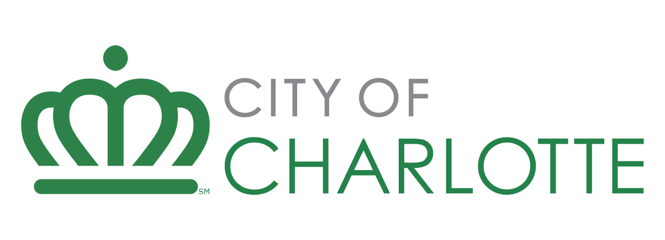

Developer Application – Housing Funding Requests

Request for Proposal/Qualifications: HOME Investment Partnership Fund (NEW CONSTRUCTION AND REHABILITATION)
Due date: Open until funds are exhausted
Developer Name: Developer Response Here
Project Name: Developer Response Here
Instructions: This document establishes a uniform approach for developers when responding to city funding opportunities for affordable housing. To ensure a smooth and efficient evaluation process, kindly adhere to the following guidelines:
Response Format: Provide your answers in short paragraphs, bulleted lists, or concise sentences. For any graphic, photo, or illustration needed, refer to it as Attachment X - Description.pdf and include it in your submission.
Completeness of Response: Fully respond to each question. If a question does not pertain to your development request, please state how the question is not applicable. I.E. “As this is a homeownership project, no property management will take place”.
Do Not Refer to External Text: Please avoid referencing external text documents in your response. Provide all relevant text in this document and attach photos, graphics, or renderings to your submission in pdf format.
Formatting: Maintain the original formatting and page breaks in your submission. This structure helps staff evaluate your response with greater accuracy. Ensure developer answers are in blue highlight.
Following these instructions can help streamline the evaluation process for your affordable housing funding opportunity proposal.

Applicant Information

- Legal Name of Business: Non-profit response here.
- Director or President: Non-profit response here.
- Type of Organization: Non-profit response here.
- Incorporation Date: Non-profit response here.
- Federal Tax ID: Non-profit response here.
- Estimated Current Fiscal Year Budget: Non-profit response here.
- Current number of staff: Non-profit response here.
- What is your Company/organization’s mission statement?
Non-profit response here.
- If the development will be held by an entity other than the applicant, provide the name of the organization here (i.e., subsidy or holding company)
Non-profit response here.
- Describe Applicant’s expertise in developing and operating affordable housing developments to include:
  - Non-profit company overview,
  - Non-profit team experience and property management
  - Experience with similar developments
  - If the Non-profit has not received multifamily housing development funding from the city in the last five years, provide at least three references that can speak directly to the applicant’s development experience. Provide as Attachment 1 – Non-profit References.pdf
Non-profit response here.
10. Are any principals, partners, employees, or others related to this transaction also employees of, or closely related to a) employees of the City of Charlotte, HUD or other relationship that may be a conflict of interest?
b) members of, or closely related to Members of, the Charlotte City Council?
c) beneficiaries of the program for which funds are requested, either as clients or as paid providers of goods or services?
If any are yes, provide a detailed explanation below. If all are no, respond no.
Non-profit response here.

Project Information

- Provide a detailed project description.
Non-profit response here.
- Provide a neighborhood narrative description and describe how the development supports/ will support the surrounding community.
Non-profit response here.
- Describe the development’s proximity to important amenities such as medical, grocery, and public transportation.
Non-profit response here.
- The City of Charlotte is seeking to maintain and significantly grow the availability of affordable housing for its residents. Please explain how the project will support this goal including affordability mechanisms and extended affordability periods.
Non-profit response here.
- Environmentally sustainable affordable housing has the potential to reduce operating costs, promote resident health, encourage resource conservation, and mitigate negative environmental impacts. Describe how your project will incorporate Green Building/Elements of Sustainability in the construction/rehabilitation and subsequent operation of the project.
Non-profit response here.
- Describe which LEED (or similar benchmark) designation your project will seek and list all energy efficiency measures planned for the project and the savings/impacts expected.
Non-profit response here
- If the property is a rehabilitation project, provide detail on the estimated remaining useful life of major systems including structural support, roofing, cladding, windows, doors, siding, gutters, plumbing, electrical, and heating, ventilation and air conditioning. * Replacement reserve must be established and confirmed if the useful life remaining is less than the period of affordability
Developer response here

- For rehabilitation projects, please describe the property standards that will be met and explain how the non-profit will ensure compliance.

Non-profit response here.
- Provide documented evidence of community engagement associated with this project. This can include but is not limited to feedback and responses from consultations.
Non-profit response here.
- Provide a rationale for how you arrived at the real estate tax value used in your proforma.
Non-profit response here.
- Describe any supportive services that will be provided at the development. If none, respond N/A.
Non-profit response here.
- Has full debt restructuring under the Market to Market process (or any similar HUD program) begun or been completed within the last 5 years?
Non-profit response here.
- Has this development received City of Charlotte financing in the last five years?
Non-profit response here.
- What is the status of the development? What other financing is in place? What is the status of site control, and is there any current construction/renovation activity?
Non-profit response here.
- Explain why city financing is needed and include any other sources of gap funding received or this project is pursuing.
Non-profit response here.
- What are the proposed loan structure and terms for the city-provided funding?
Non-profit response here.
- Describe any UDO Affordable Housing bonuses this development will seek.
Non-profit response here.

Property Management

- Name of proposed property management firm.
Non-profit response here.
- Provide a list of up to five properties currently managed by this firm.
Non-profit response here.
- List properties managed by the proposed management that have been in default in the last ten years.
Non-profit response here.
- Provide a detailed property management plan.
Non-profit response here.
- Provide a detailed outreach and marketing plan for the development.
Non-profit response here.

Legal & Environmental

- Provide the legal land description.
Non-profit response here.
- Describe any historically significant conditions requiring Historic Review. If none, respond N/A.
Non-profit response here.
- Description of any environmentally significant site condition(s). If none, respond N/A.
Non-profit response here.
- Disclose any outstanding judgments or litigation. Provide an explanation for each item. If none, respond N/A.
Non-profit response here.

Previous Experience

- List previous city funding received. Add rows as needed.
Development/ Project Name | Funding Amount | Development/ Project Status
Sample Project | $1,000,000 | Financing Closed, Under Construction

