**“Example”**

**Sanitary Sewer Collection System Operation and Maintenance Plan**

**Please edit all the information that is highlighted. Only include information that is relevant to your community. For example, if you do not have a pump station, remove that language.**

Updated Month and Year

**Name of Apartment Community**

**XYZ Property Management Company**

**ADDRESS**

**Charlotte, NC ZIP CODE**

**PHONE NUMBER**

1. **Sewer System Maintenance**

It is advised that the system be cleaned to prevent discharge to land or surface waters. Name of Plumbing Company has been contracted to perform the system cleaning. As part of the cleaning, they will collect and remove as much dislodged debris from the system as possible. Receipts for system cleaning are filed with this Operation and Maintenance Plan. Charlotte Water will be contacted a week before any cleaning occurs, or as soon as possible.

1. **Collection System Map**

System map has been created and is included as Attachment A.

1. **Operation and Maintenance Plan**

The Plan has been developed and implemented including pump station inspection frequency, preventative maintenance schedule, spare parts and inventory, and overflow response procedures.The following spare parts and equipment are maintained onsite at all times:

* Clean-out caps
* Manhole lifting tool (pick or puller)
* Debris removal tool (sanitary sewer rake, scoop, paddle or retrieval device)
* Auger machine and/or plumber’s snake
* Personal protective equipment (i.e., rubber boots, gloves and clothing)
* Spill response clean-up kit which includes a spill barrier device (boom or sock), hydrated lime, and trash bags for debris disposal

1. **Pump Stations**

*If applicable; if not, include a statement that there are no pump stations.*

A pump station inspection is conducted weekly if telemetry is present *or* daily if telemetry is not present. The inspection is conducted by [NAME OF PERSON or COMPANY]. Inspections are documented in a log book. The inspection includes:

1. Test audible and visual alarms
2. Test telemetry
3. Test level control floats
4. Test pumps
5. Inspect for the presence of debris or build-up. Debris and build-up will be removed as it accumulates.

In the event the power to the pump station is interrupted, contact [Name of Person or Company] immediately to secure an alternate power source.

1. **High-Priority Sewer Lines**

*If applicable; if not, include a statement that there are no high priority sewer lines. Examples of high priority lines are aerial lines that cross a creek and/or a problem area(s) in the system where debris builds up most often.*

High-priority sewer lines are inspected at least once every six months. If debris is observed, staff will remove it or call 311 to have it removed.

1. **Collection System Inspection**

The entire system is inspected annually. Inspections are documented in the Inspection Log included as Attachment B. The inspection includes:

1. Manholes

* Open manhole cover and observe flow conditions
* Inspect for the presence of debris or build-up

1. Aerial lines that cross the creek

* Inspect couplings
* Evaluate piers
* Remove woody debris that is lodged on the upstream side of the lines or call 311 if staff cannot safely remove it.

1. Clean-outs

* Ensure all clean-outs have their caps in place
* Inspect for the presence of debris or build-up

1. Right-of-Way

* Remove underbrush and tree saplings from the right-of way as needed.

1. **Overflows and Back-Ups – Response and Reporting**

An Overflow Incident Report Form is completed for all overflows or back-ups. The Overflow Incident Report Form is included as Attachment D. Response Procedures are as follows:

* Contact Maintenance Supervisor NAME, PHONE and the North Carolina Department of Environmental Quality (NCDEQ) - Mooresville Regional Office at (704) 663-1699.
* Contact a plumber or make sure someone else is contacting one. The plumber must be able to be onsite within 4 hours. If the plumber is not able to be onsite within 4 hours, contact another plumber. A list of contact numbers are as follows:
  + PLUMBER NAME, PHONE
  + PLUMBER NAME, PHONE
  + PLUMBER NAME, PHONE
* Fill out an Overflow Incident Report Form, which is included as Attachment D.
* Take photos and attach them to the Overflow Incident Report Form.
* Ensure that either maintenance or the contracted plumber removes solids and spreads hydrated lime. Make sure lime is not spread in the creek. Lime is located in the location where lime is stored.
* If the problem is isolated to a particular building, distribute grease education materials to residents in that building.
* If there are problems or questions, contact the Service Manager.

1. **Grease Education for New and Current Residents**

Educational materials are distributed to residents at least twice a year. This activity is documented in the Inspection Log.

Examples:

* Grease posters are posted in the location(s) where posters were posted.
* A Grease Free Lease Addendum is attached to all new leases and signed by all new residents and current residents when they renew their lease. The addendum is included as Attachment C.

1. **Right-Of-Ways and Easements**

Right-of- ways and easements are maintained to allow for ease of access necessary for system maintenance.

1. **Inspection Records**

Inspection records are documented and maintained for a period of three years in Attachment B. The system map is maintained for the life of the system.

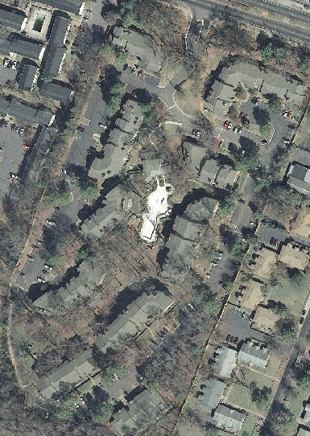

**Attachment A**

**EXAMPLE**

**Name of Apartment Community Sewer Collection System Map**

**MH5**

**MH4**

**MH3**

**MH2**

**MH1**

Manhole Pump Station Direction of Flow

**Attachment B**

**COLLECTION SYSTEM INSPECTION LOG**

**Name of Apartment Community**

|  |  |  |  |  |
| --- | --- | --- | --- | --- |
| **Inspected By** | **Date** | **System Inspection (Comments/Problems/Actions Required)** | **System Maintenance (Comments/Problems)** | **Grease Education Distributed** |
|  |  |  |  |  |
|  |  |  |  |  |
|  |  |  |  |  |
|  |  |  |  |  |
|  |  |  |  |  |
|  |  |  |  |  |
|  |  |  |  |  |
|  |  |  |  |  |

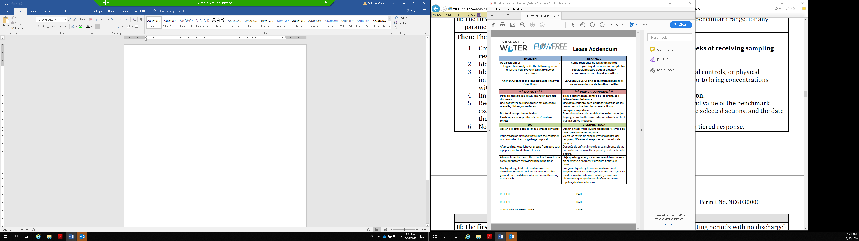**Attachment C**

**Attachment D**

**Overflow Incident Report Form**

**Name of Apartment Community**

**Emergency Contact Numbers:**

John Doe, Maintenance Supervisor –PHONE NUMBER

Name of Plumbing Company – PHONE NUMBER

NCDEQ - Mooresville Regional Office – (704) 663-1699

|  |  |  |  |  |  |
| --- | --- | --- | --- | --- | --- |
| Date/Time | Incident Location | Weather Conditions | Incident Description  (Cause) | Actions Taken to Correct Problem | Pictures Taken? |
|  |  |  |  |  |  |
|  |  |  |  |  |  |
|  |  |  |  |  |  |
|  |  |  |  |  |  |
|  |  |  |  |  |  |
|  |  |  |  |  |  |
|  |  |  |  |  |  |
|  |  |  |  |  |  |
|  |  |  |  |  |  |
|  |  |  |  |  |  |
|  |  |  |  |  |  |
|  |  |  |  |  |  |
|  |  |  |  |  |  |
|  |  |  |  |  |  |
|  |  |  |  |  |  |
|  |  |  |  |  |  |