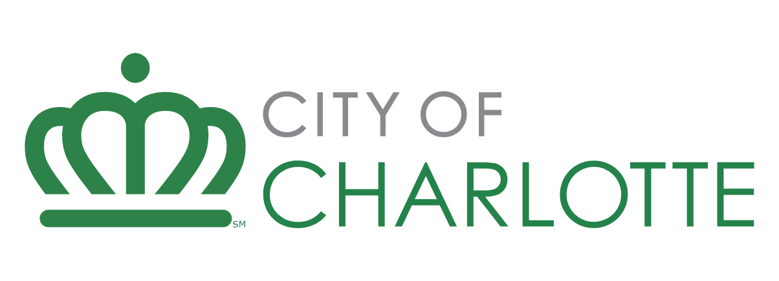

Developer Application – Housing Funding Requests

Request for Proposal/Qualifications: Charlotte Mecklenburg HOME Consortium Investment Partnership Fund – DOWN PAYMENT ASSISTANCE (DPA)
Due date: Open until funds are exhausted
Developer Name: Non-profit Response Here
Project Name: Non-profit Response Here
Instructions: This document establishes a uniform approach for developers when responding to city funding opportunities for affordable housing. To ensure a smooth and efficient evaluation process, kindly adhere to the following guidelines:
Response Format: Provide your answers in short paragraphs, bulleted lists, or concise sentences. For any graphic, photo, or illustration needed, refer to it as Attachment X - Description.pdf and include it in your submission.
Completeness of Response: Fully respond to each question. If a question does not pertain to your development request, please state how the question is not applicable. I.E. “As this is a homeownership project, no property management will take place”.
Do Not Refer to External Text: Please avoid referencing external text documents in your response. Provide all relevant text in this document and attach photos, graphics, or renderings to your submission in pdf format.
Formatting: Maintain the original formatting and page breaks in your submission. This structure helps staff evaluate your response with greater accuracy. Ensure developer answers are in blue highlight.
Following these instructions can help streamline the evaluation process for your affordable housing funding opportunity proposal.

Applicant Information

- Legal Name of Business: Non-profit response here.
- Director or President: Non-profit response here.
- Type of Organization: Non-profit response here.
- Incorporation Date: Non-profit response here.
- Federal Tax ID: Non-profit response here.
- Estimated Current Fiscal Year Budget: Non-profit response here.
- Total HOME funding requested: Non-profit response here
- Current number of staff: Non-profit response here.
- What is your Company/organization’s mission statement?
Non-profit response here.
- Describe Applicant’s expertise in delivering DPA to include:
  - Non-profit company overview,
  - Staff experience and property management
  - Experience with administering DPA
  - If the Non-profit has not received DPA funding from the city in the last five years, provide at least three references that can speak directly to the applicant’s DPA experience. Provide as Attachment 1 – Non-profit References.pdf
  - Describe the process your agency has in place to ensure that all staff understand and will meet HOME DPA contract requirements for required reporting and invoice submittal.
  - If you were unable to use all allocated HOME funding awarded in FY2024 (July 2023-June 2024) provide an explanation and any strategies used to utilize funding.
Non-profit response here.
10. Are any principals, partners, employees, or others related to this transaction also employees of, or closely related to a) employees of the City of Charlotte, HUD or other relationship that may be a conflict of interest?
b) members of, or closely related to Members of, the Charlotte City Council?
c) beneficiaries of the program for which funds are requested, either as clients or as paid providers of goods or services?
If any are yes, provide a detailed explanation below. If all are no, respond no.
Non-profit response here.

Project Information

- The City of Charlotte seeks to maintain and significantly grow the availability of affordable housing for its residents. Please explain how the project will support this goal, including affordability mechanisms and extended affordability periods.
Non-profit response here.
- The goal of City funding for down payment assistance is to provide funds to eligible homebuyers to help with down payment and closing costs on a home. For eligible homebuyers discuss your agency’s long-term housing strategy plan to ensure the homebuyers sustain their ownership.
Non-profit response here
- Has this project received City of Charlotte financing in the last five years?
Non-profit response here.
- What is the status of the project? What other financing is in place?
Non-profit response here.
- Explain why HOME funding is needed and include any other sources of gap funding received or this project is pursuing.
Non-profit response here.
- What are the proposed loan structure and terms for the HOME funding?
Non-profit response here.

Previous Experience

- List previous HOME funding received. Add rows as needed.
Development/ Project Name | Funding Amount | Development/ Program/Project Status
Sample Project | $1,000,000 | Financing Closed, Under Construction

COMMERCIAL NON-DISCRIMINATION CERTIFICATION

COMPANY NAME:

RFP NAME: | FY2025 HOME DPA

RFP NUMBER:

The undersigned Non-profit hereby certifies and agrees that the following information is correct:
- In preparing its bid/proposal, the Company has considered all bids/proposals submitted from qualified, potential subcontractors and suppliers and has not engaged in discrimination as defined in Section 2 below.
- For purposes of this section, discrimination means discrimination in the solicitation, selection, or treatment of any subcontractor, vendor, supplier or commercial customer on the basis of race, ethnicity, gender, age, religion, national origin, disability or other unlawful form of discrimination. Without limiting the foregoing, discrimination also includes retaliating against any person or other entity for reporting any incident of discrimination.
- Without limiting any other remedies that the City may have for a false certification, it is understood and agreed that, if this certification is false, such false certification will constitute grounds for the City to reject the bid/proposal submitted with this certification and terminate any contract awarded based on such bid/proposal. It shall also constitute a violation of the City’s Commercial Non-Discrimination Ordinance and shall subject the Company to any remedies allowed thereunder, including possible disqualification from participating in City contracts for up to two years.
- As a condition of contracting with the City, the Company agrees to promptly provide to the City all information and documentation that may be requested by the City from time to time regarding the solicitation and selection of subcontractors and suppliers. Failure to maintain or failure to provide such information shall constitute grounds for the City to reject the bid/proposal and to terminate any contract awarded on such bid/proposal. It shall also constitute a violation of the City’s Commercial Non-Discrimination Ordinance and shall subject the Company to any remedies that are allowed thereunder.
- As part of its bid/proposal, the Company shall provide to the City a list of all instances within the past ten years where a complaint was filed or pending against the Company in a legal or administrative proceeding alleging that the Company discriminated against its subcontractor, vendors, suppliers, or commercial customers, and a description of the status or resolution of that complaint, including any remedial action taken.
- As a condition of submitting a bid/proposal to the City, the Company agrees to comply with the City’s Commercial Non-Discrimination Policy as described in Section 2, Article V of the Charlotte City Code, and consents to be bound by the award of any arbitration conducted thereunder.

Signature of Authorized Representative (or Designee)

(Print Name)

(Title)

(Date)

STAFFING
NON-PROFIT NAME: | Click or tap here to enter text.

RFP NAME: | FY2025 HOME DPA
List the full names of all employees whom you intend to assign to this program. Describe their specific role/responsibility and availability. Add additional pages as necessary.
Employee Name & Title | Project Role | Availability | Education / Experience
John Smith, Counselor | Program eligibility client services | Full time staff assigned 50% to this program | MSW
Click or tap here to enter text. | Click or tap here to enter text. | Click or tap here to enter text. | Click or tap here to enter text.
Click or tap here to enter text. | Click or tap here to enter text. | Click or tap here to enter text. | Click or tap here to enter text.
Click or tap here to enter text. | Click or tap here to enter text. | Click or tap here to enter text. | Click or tap here to enter text.
Click or tap here to enter text. | Click or tap here to enter text. | Click or tap here to enter text. | Click or tap here to enter text.
Click or tap here to enter text. | Click or tap here to enter text. | Click or tap here to enter text. | Click or tap here to enter text.
Click or tap here to enter text. | Click or tap here to enter text. | Click or tap here to enter text. | Click or tap here to enter text.

The information provided in this proposal requesting Down Payment Assistance is true and accurate to the best of my knowledge. I acknowledge that if funding is awarded to my agency, HUD HOME funding rules and regulations apply to the use of this funding.

Click or tap here to enter text.
_________________________________________________________________________________
Executive Director or Designee Signature

Click or tap here to enter text.
__________________________________________________________________
Date

The City of Charlotte is seeking qualified non-profit agencies to administer Down Payment Assistance (DPA) that will provide financial assistance to eligible home buyers for down payment and closing costs on a home.

Overview
The DPA program will follow all HOME regulations such as owner occupancy, affordability period and income requirements, unit and payment standards, and administrative performance. The City of Charlotte will also examine program performance indicators, such as program participation levels, outreach efforts, sustainability of persons within the program, and other performance indicators that will be incorporated into all contracts.
The intent of this RFP is to identify agencies that can best administer DPA to enable residents to purchase a home within the program area. The proposing non-profit must be agreeable to administer the DPA as designed and agree to comply with all HOME regulations and City contract requirements.

1.1 Important HOME DPA Requirements

Eligible Units
Assisted households may identify the housing unit of their choice. Eligible properties may be publicly or privately owned and new construction homes must meet minimum local and state Housing Code. DPA may be used in HOME-assisted units, but the property does not have to be a HOME-assisted unit. The unit must be located within the footprint of the Charlotte Mecklenburg HOME consortium partners jurisdiction. Non-profits must ensure that homes are maintained in compliance with the property standard of for the duration of the HOME period of affordability.

1.2 Sales Price
Units sold under this program must be available to buyer(s) whose households are 80% or less AMI. The closed sales price must not exceed those listed within the HUD HOME sales price maximum for the county in which the project will be located. Housing is considered affordable when households pay no more than 30% of their income for housing costs, including utilities. The city assumes households spend no more than 2% of their income on utilities. Before a sales contract is approved, the developer/ non-profit must provide the buyers loan disclosure for affordability confirmation.

1.3 Other Key Requirements
The US Department of Housing and Urban Development requires HOME funded DPA projects meet the following requirements:
- The agency must select homebuyers based on written homebuyer selection policy and criteria;
- Home buyers must receive title in either fee simple or a minimum 99yr lease. The City must approve the lease used to ensure protection of the homebuyers rights;
- Length of DPA assistance must be for the term of the mortgage or until the beneficiary sells the property. If the home is sold within the HOME affordability period, the recapture provision must be exercised.
- The City is required will monitor its each agency’s program on an ongoing basis to ensure compliance with HOME Program requirements. At a minimum, monitoring will include:
  - Verifications that the agency receiving DPA funds is conducting initial and annual inspections to determine that the unit continues to meet property standards,
  - Verification of homebuyer(s) income to ensure assisted households are low to moderate income at the point of initial home purchase, and
  - Review of monthly housing related payments to determine that the housing costs remain reasonable and sustainable to the home buyer.

Income Limit Chart

